EXPERIMENT 1 – Kanban Board to Visualize Tasks (Jira)
AIM
To create a Kanban Board to visualize tasks and simulate the workflow using Jira.
PROCEDURE
- Open Jira and sign in to your account.
- Create a Jira software project named Student Project and open its Kanban board.
- Set up three board columns named To Do, In Progress, and Done.
- Add a issue named Gather Project Requirements to the To Do column.
- Add a issue named Prepare Project Plan to the To Do column.
- Add a issue named Design User Interface to the To Do column.
- Add a issue named Develop Application to the To Do column.
- Add a issue named Test Application to the To Do column.
- Review the five sample tasks and arrange them in the required order.
- Move Gather Project Requirements from To Do to In Progress.
- Move Gather Project Requirements from In Progress to Done after completion.
- Move Prepare Project Plan from To Do to In Progress.
- Move Prepare Project Plan from In Progress to Done after completion.
- Move Design User Interface from To Do to In Progress to indicate ongoing work.
- Keep Develop Application and Test Application in To Do as pending tasks.
- Verify that the board displays tasks in all three columns and reflects the workflow.
OUTPUT:
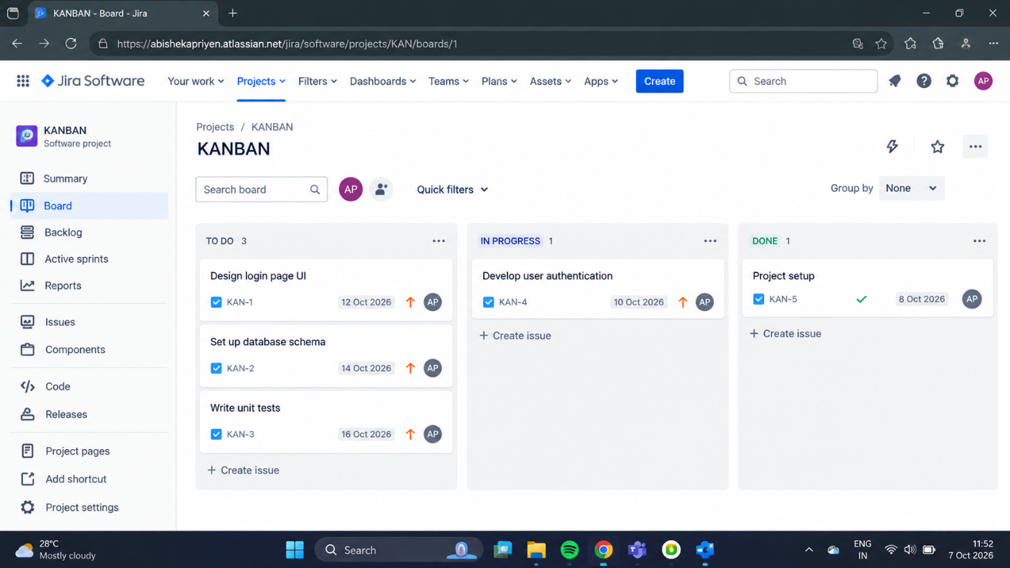
RESULT:
Thus, the Kanban Board was created successfully with To Do, In Progress, and Done columns, and tasks were moved across the columns to simulate the workflow.

